LAB SESSION 3
Programming Exercise:
Question 1: Define a structure named Person with members name and age. Create a variable of this structure type, initialize it, and display its contents.
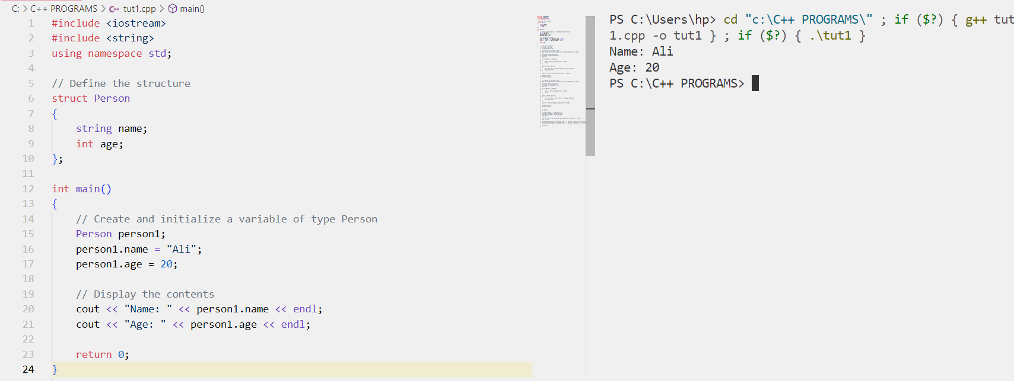

Question 2: Define a structure named Rectangle with members length and width. Create a variable of this structure type, input values for length and width, calculate the area, and display it.
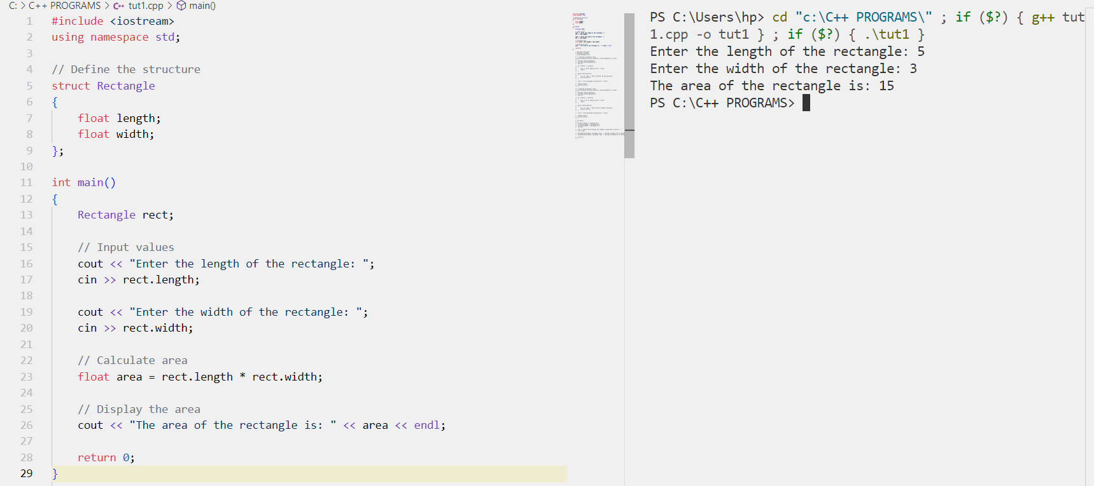
Question 3: Define a structure named Number with a single member num. Create two variables of this structure type, input values for them, swap their values using a function, and display the swapped values.
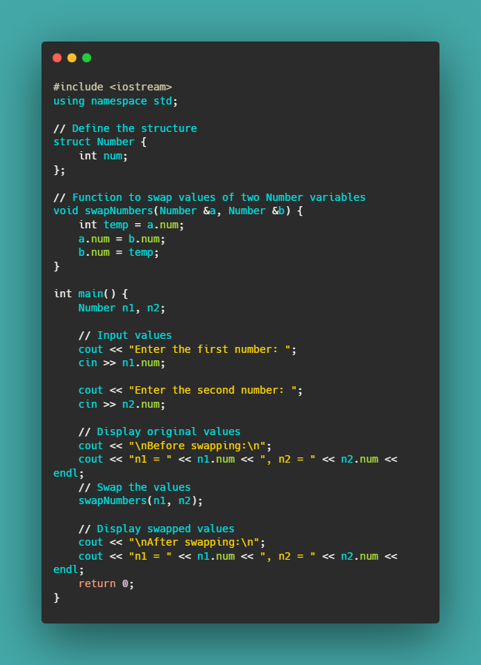
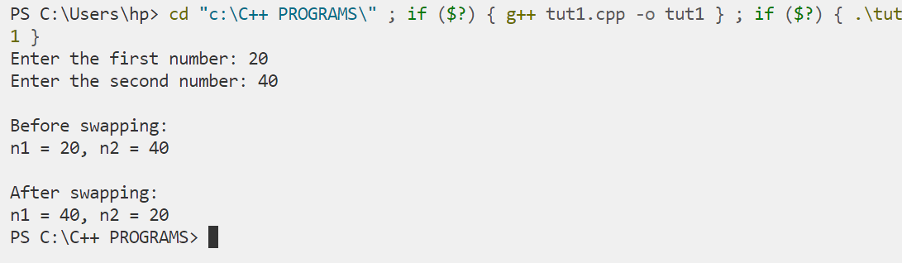

Question 4: Define a structure named Student with members rollNumber, name, age, and marks. Create an array of 3 Student structures, input data for each student, display their details, and find the student with the highest marks.
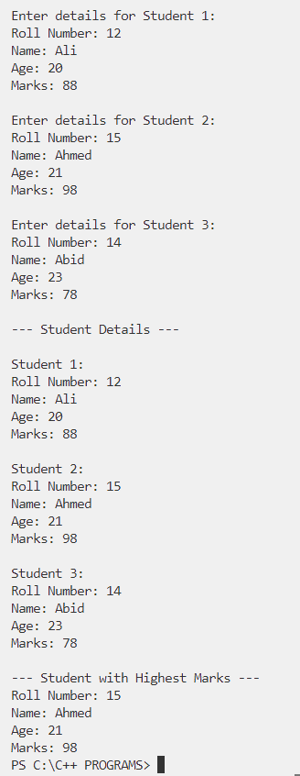
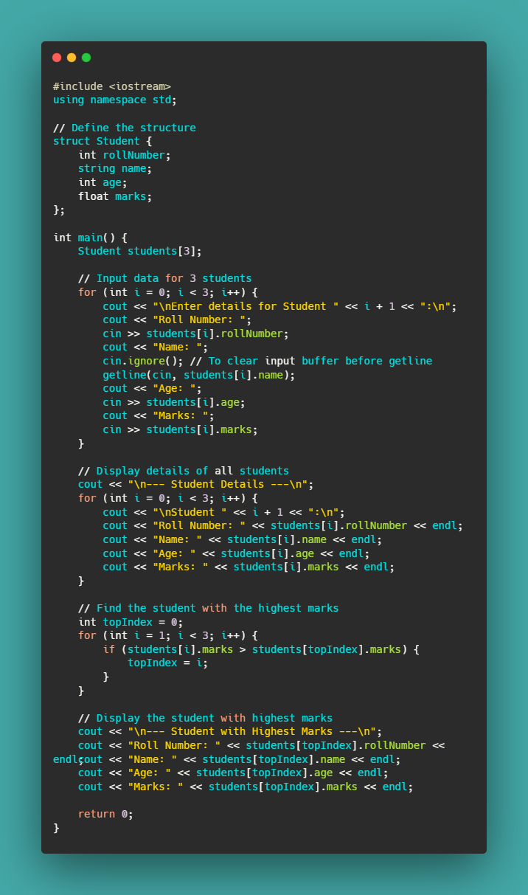
Question 5: Define a structure named Employee with members employeeID, name, department, and salary. Create an array of 5 Employee structures, input data for each employee, display their details, and calculate the average salary of all employees.
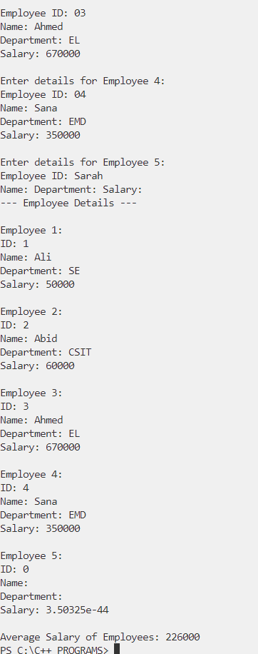
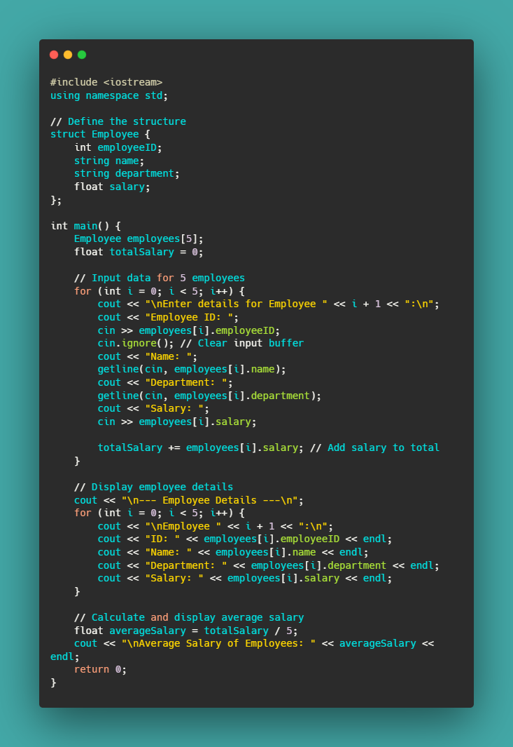
Question 6: Define a structure named Book with members title, author, genre, and yearOfPublication. Create an array of 3 Book structures, input data for each book, display their details, and find the book with the earliest publication year.
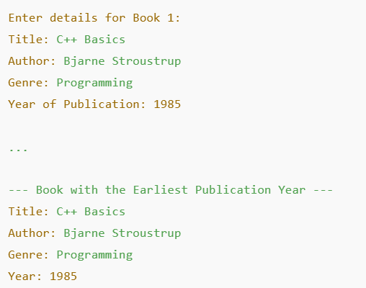
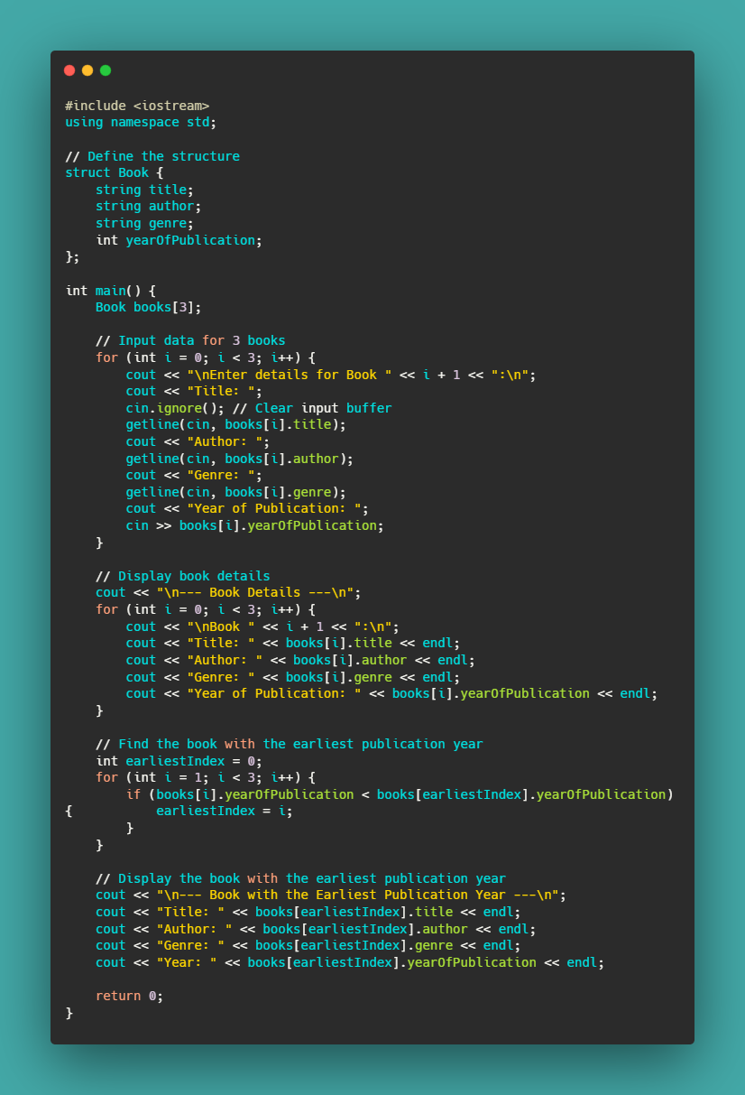

Question 7: Define a structure named Product with members productName, price, and quantity. Create a variable of this structure type, input data for the product, calculate the total cost, and display it.
